**DEC,2013-JULY 31, 2017**

**Initial Annual Report**

**nn**

**Historic Women’s Public Art Exhibit**

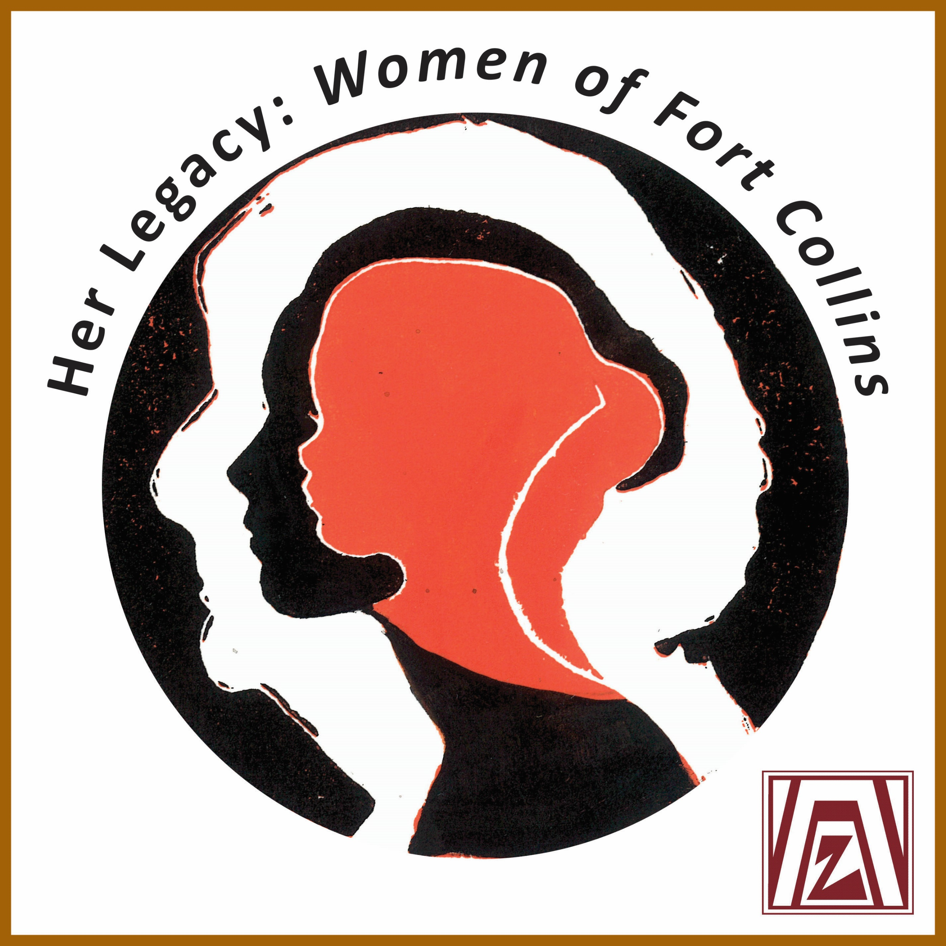

[www.ZontaFCevent.com](http://www.ZontaFCevent.com)

**www.ZontaFCevent.com**

Zonta Club of Fort Collins Foundation Name



Zonta Club of Fort Collins Foundation Name

www.HerLegacyZontaFC.com

**Annual Report**

**nn**

Message from Patti Smith, Legacy Chair **3**

Mission & Process **4**

Programs Impact & Testimonies **5**

Impact & Benefits **6**

Planning Committee **7**

Community Partners, Events & Marketing **8**

Donor Thank you **9**

Resources & Fiscal Management **10**

Looking Forward **11**

First 24 women **12**

We Need Your Help **13**

**SAMPLE NONPROFIT, INC**

**CONTENTS**

**Message from Legacy Chair**

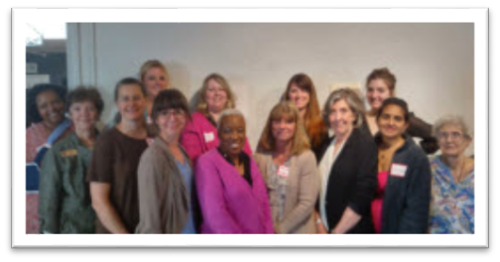

The first group of community women to join our selection committee, April 2015, to help initiate this project.

Dear Friends,

We are very grateful for each of you as you have provided support to help us bring this dream into a reality for our community. You may not know where this project originated from…

At the convention center in Denver on the East side wall under the overhang of a supply driveway, there are 80 mosaics portraits-40 women and 40 men-who all had a hand in the creation of our great state of Colorado. I investigated this Colorado Panorama art project in 2013 and thought if they can do this in Denver, why couldn’t we do this in Fort Collins and our journey began.

We are an International women’s service organization that works to empower women globally and locally through service, advocacy and education events.

Far too often, women’s achievements have been ignored, under reported, men given credit, or simply erased from the historical record. There have been many research, and other articles written from such entities as Wall Street Journal, Pew Research Center, Harvard Business Review, Stanford University, National Geographic, Scientific Journals and more. Here is but one example: https://www.bustle.com/p/9-times-men-were-given-credit-for-womens-historic-accomplishments-41120.

You have heard, “it takes a village” I am sure, and this statement is certainly true.

None of us can raise a family, build a business, recognize women’s accomplishments or impact a community totally alone. I’ve seen what a village, an organization and a community of women can do, one action at a time. And I’ve seen how women can help women.

Our Vision: To recognize women’s accomplishments and to inspire the next generation of women.

Mother Teresa stated: “I alone cannot change the world, but I can cast a stone across the waters to create many ripples.” Our Zonta Club of Fort Collins Foundation has cast a stone creating many ripples.

Thank you for joining us on this journey.

Patti A. Smith, RN

**Mission**

3

*Our mission with this project is: As women of Zonta, we are creating Her Legacy Project to inspire women and girls to discover themselves in the many talents, contributions, and achievements of women, both past and present, in our Fort Collins community. “Inspiring Girls and Women to Create Their Own Legacies"*

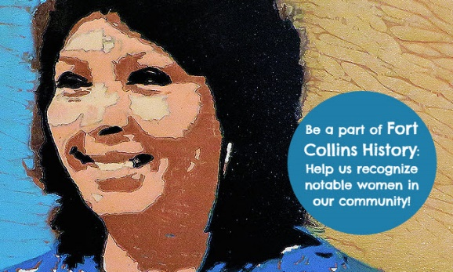**Process**

Approval Process

Our local club has been approved to create a public historic art exhibit recognizing women’s achievements. We are a part of the Old Town renovation project and we are honored to be provided the opportunity to introduce our community to 48 women’s accomplishments. This project was approved by the DDA, Old Town Property Management, Cooper Smith’s Brewery and the Fort Collins Historic Preservation Society.

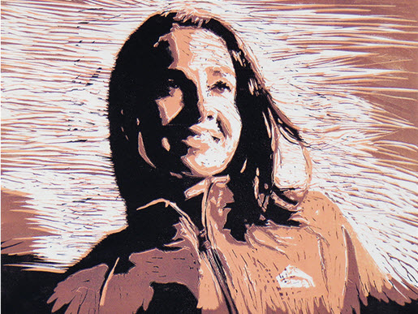 Selection Process

We invited men and women from our community to nominate a woman they thought should be recognized for their accomplishments. We invited women from our community to sit on a selection committee to help review the nominations received and select the 48 notable women to be recognized in this art exhibit.

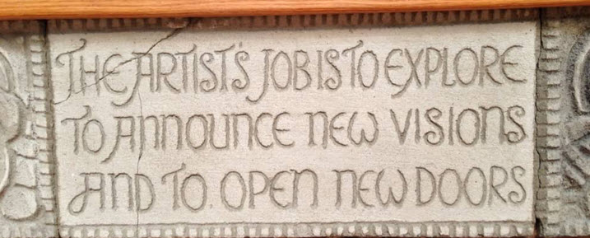 Artists

4

**Rachael Davis** MFA/CSU, Project Art Director/Portrait Artist. Was an Art Instructor at FRCC/LC and is Art Instructor at Rocky Mountain Art Institute, Denver and has been invited to participate in several International Art Shows back east, one of 35 finalists out of 1100 entrants. Visit <http://www.rachaelynndavis.com/>

**Trish Murtha** Portrait Artist/Role Model Workshop Facilitator. A very talented water color artist. Trish Murtha, a professional artist and her 20 years of award-winning watercolors are a unique source for surface design and collections, and her portfolio reaches from contemporary to fine art, including whimsical, timely images. Visit <http://trishmurthadesigns.com/>

**Isis Lanigan**: Portrait Artist. Skilled in Photography, Drawing, Fine Art, Sculpture and Adobe Photoshop. Poudre School District PT, Freelance Photographer. Strong community and social services professional with a BA/CSU. Aspires to be an entrepreneur in the arts and make a positive difference in the lives of others. www.IsisLanigan.com

**Belgin Yucelin**, a sculptor from Boulder will create the 6 hand-sculpted bronze frames specifically designed to add to the artistic excellence of the project. Visit <https://belginyucelen.com/>

**Program Impact**

"Inspiring Girls and Women to Create Their Own Legacies"

Our Criteria:

1. Visionaries for Change by following their heart's passion.

2. Role Model for girls and women.

3. Made a Difference demonstrating her commitment, courage and resilience.

T h These notable women’s accomplishments have contributed to our Fort Collins legacy.

**Testimonies**

Karen McWilliams, FC Historic Preservation *Society “I strongly support the Zonta Club of FC ‘Women’s Legacy Mural.’ I want my daughter to be exposed to and appreciate the significant contributions of women to our community throughout FC History.”*

Matthew Robenalt, DDA Executive Director *“Storytelling through art is a powerful form of Interpersonal communication, particularly when communicating an authentic experience of a city. The Zonta Club’s mural project, which will be highly visible to local and tourism guests of Old Town Square, imparts the spontaneity of publicly displayed art and place-making with the importance of reflecting on the stories of people that have made Fort Collins an intriguing place to visit, live, work and play.”*

Katy Schneider, Marketing Director Visit Fort Collins *“Fort Collins has a large appreciation for public art and adding an element of personal story telling through photographs would only heighten the attractiveness of the variety we have to offer visitors.”*

**Donor Comments**

*~ Hooray! What a great project ~ A great project supporting local women ~ Good luck! ~ ~This is such a worthwhile project! ~ So excited to see women being recognized for the incredible work they do every day. This project is a big step forward for women everywhere! ~ I look forward to reading about each woman’s legacy ~ Projects like this are so important, and I’m glad that these women are getting the recognition they so deserve ~I chose to give because women’s contributions to Fort Collins are and have been vital to the community and so need to be recognized ~ Wonderful program! ~ Good luck, I hope you make your goal! ~ In honor of the women of Fort Collins~ Women’s contributions have so long been overlooked or forgotten, so I support anything that helps bring these stories to light ~*

5

**Impact Continued**

Our Poudre School District has agreed to partner with us and invite their teachers to write curriculum about these women’s life journey’s for 2nd grade Fort Collins History, 4th grade Colorado History, Middle/High School Social Studies and for Art Classes. Also, the Colorado State University Women’s Studies and Research Department will include their stories into a class curriculum.

Through the curriculum which will be written by Colorado State University and Poudre School District, many families in our community will learn about these women through the instruction of their children and the projects associated with this instruction.

One of Zonta collaborators at Poudre School District, Laura Cronen, District Art Coordinator, said the following about the project:

*“Upon learning about the Her Legacy: Women of Fort Collins mural project I was excited for the unique addition to the culture of the Fort Collins community. The renderings by artist Racheal Davis capture each of the women represented in a wood cut print that have a timeless quality and will be enjoyed for years to come. Additionally, as the Visual Arts Curriculum Facilitator in Poudre School District, I look forward to collaborating with the Zonta Club to bring the artworks and historical information surrounding each of the chosen significant women in the Fort Collins Community to the schools. This will highlight both the arts and the accomplishments of women in Fort Collins, and serve as an inspiration to girls and women to reach for their dreams as they learn about influential women, past and present, in their own community.”*

**Benefit to local sponsoring business**

*Being a part of history by helping bring these women’s stories to life in our community

*Logo permanently in Old Town on Her Legacy art exhibit windows

**Project Benefit to the Community**

•Recognition through other Colorado Welcome Centers

•Add to Fort Collins’ identity as a cultural center and tourist destination

•Potential revenue addition to city due to visits to see the Zonta Women’s Legacy Mural

•Add to economic vitality and use of these Old Town spaces

• Partnerships with and participation by local PSD, FRCC/LC and CSU

•Traveling art exhibits within Fort Collins and surrounding communities

•Art in Public Places, a city department project guideline, is for an esthetically pleasing and informative art display

•Part of the Downtown Alley Enhancement project into Old Town from East

•Helping to fulfill part of Goal #3 of the 2008 Fort Collins Cultural Plan

Her Legacy: Women of Fort Collins has the potential to affect millions of people. The Visit Fort Collins office estimates over 1 million visitors come to Fort Collins each summer as a destination. If even 1% of these visit Old Town (100,000) and 10% of Old Town visitors view Her Legacy: Women of Fort Collins, 10,000 visitors a year will view the portraits and have an opportunity to learn about these women. Based on Poudre School District October count 2014-15 numbers we estimate that, at a minimum, over 10,167 students/guests will benefit each school year. In addition, about 720 students are enrolled in Women’s Studies major at Colorado State University. So, our potential yearly audience is easily over 21,887 a year.

**Planning Committee**

Our planning committee has grown organically. In Fall of 2013 I shared the idea with Rachael Davis, an artist and Zonta member to see what she thought might work for portraits. During 2014 I met with numerous City of Fort Collins employees to obtain the approval to install this art exhibit in Old Town, Fort Collins. Rachael and I took several grant writing workshops, wrote grants that year and worked to recruit women from our community to participate in the nomination and selection process.

6

We facilitated the first Selection committee event April 2015 with thirteen women out of twenty invited. We shared our vision and shared initial thoughts on criteria for the selection process. The women shared their suggestions and one woman, a life coach volunteered her time to help us determine our mission, vision and criteria. After this meeting, there were two other women who joined our committee: Heather Bonnema, Graphic Designer and Kirsten Johnson, Marketing Liaison. The four of us met with Judith Hammon, Life Coach as she walked us through a procedure to come up with the following:

As women of Zonta, we are creating Her Legacy Project to inspire women and girls to discover themselves in the many talents, contributions, and achievements of women, both past and present, in our Fort Collins community.

"Inspiring Girls and Women to Create Their Own Legacies"

Our Criteria:

1. Visionaries for Change by following their heart's passion.

2. Role Model for girls and women.

3. Made a Difference demonstrating her commitment, courage and resilience.

Our selection committee events have been held as follows:

Introduction event: April 2015; July 2015 1st selection of 1st twelve notable women events; February 2016 2nd selection of 2nd twelve notable women events: January 2017; selection of 3rd twelve notable women; April 2017 selection event discussion; May 2017 selection of 4th twelve notable women.

Two planning committee members had to leave committee: Heather Bonnema, GD/Chelsea Glanz, Artist

Our Planning Committee now has the following members:

Patti Smith, Legacy Chair; Rachael Davis, Project Art Director/Portrait Artist

Barbara Fleming, Writer/Author, Coloradoan History Columnist; Kirsten Johnson, Corresponding Secretary

RJ Clay, Videographer; Stacey Jensen, Grant Writer

Michel Olds, Accountant/Foundation Treasurer

Angela Kettle, Fundraising Program Facilitator/Social Media Consultant

Alyse Smith, Graphic Designer, Trish Murtha, Role Model Workshop Facilitator/Portrait Artist;

Isis Lanigan, Portrait Artist; Julie Ulstrup, Photographer

All selected women sign a participation contract.

We hope that these visually appealing artistic portraits, will be the reason visitors stop and take a moment to visit the exhibit and then the website to read about these women. We believe that learning about women who have been visionaries for change by following their heart’s passions can become role models for girls and women and inspire others to make a difference through commitment, courage and resilience as modeled by these notable honorees.

7

**Our Community Partners:**

DEC 2013: Kathy Gilliland, Former Mayor Loveland and Zonta Meet the Author MC/shared vision and referred to Matt Robenalt

Spring 2014: Approved by Downtown Development Authority/Matt Robenalt

Ed Stoner/Old Town Properties

Dwight Hall/Cooper Smith Brewer, Managing Partner

Final Approval from Fort Collins Historic Preservation Society-DEC 2014

Meetings held 2014 with and input received from the following:

Lesley Drayton: Fort Collins Museum Curator History Archives

Katy Schneider and Lindsey Rohrbaugh: Visit Fort Collins

Linda Ellis: Colorado Welcome Center

Anne Macdonald: Harmony Library non-profit funding software

Derek Getto: Downtown Development Authority/planning process

Jennifer Hensley: DDA/Summer Art exhibits in Old Town

Karen McWilliams: Fort Collins Historic Preservation Society

Gail Budner/Jill Stilwell: Fort Fund/Cultural Services

Kathy Jack-Romero/Publisher Coloradoan

Spring 2015: Sarah Scobey: Fort Collins Library Non-profit Support Director

Poudre School District: Robert Beauchamp, Director of Curriculum, Instruction and Assessment

Connecting Signs: Brooke Gardner, CO-Owner

**Events**

2015 Spring Legacy hands-on children’s’ art project in Old Town

2015 Fall Fashion Show Blue Harvest Apparel

January 2016 1st Annual Fundraiser OpenStage Theatre play donated by Susan Larson- Outside Mullingar

June 2016 1st High Tea Introduction/Recognition event at Avery House gardens of first 24 women selected

March 2017 1st Donor Appreciation event at Cooper Smith’s Brewery/Poolside Restaurant

**Marketing**

2015 Website created with WIIX [www.HerLegacyZontaFC.com](http://www.HerLegacyZontaFC.com)

2015 Facebook site created @HerLegacyFortCollins and created Her Legacy business cards

December 2015 January OpenStage Program ad

January 2016 Living in Fort Collins and Living in Northern Colorado magazines ad and very nice article

June 2016 Coloradoan article about art exhibit and first 24 women

May 2016 Crowdfunding ad and created Her Legacy Crowdfunding business cards

August 2016 Style Magazine wonderful article about June High tea event with Zonta on front cover Fall 2016 OpenStage Program ad and OCT 16th Crowdfunding ad in Coloradoan

8

April 2017 Coloradoan Thank You Donor ½ page ad

May 2017 Coloradoan exhibit ad and donation ad Quarter 1, Quarter 2 and Quarter 3 2017 Discover Fort Collins magazine 1st twelve legacy women’s recognition

Marketing as a member of Red Carpet Chamber and several networking groups for three years

**Donors Thank You for your generosity…**

|  |  |  |  |  |  |
| --- | --- | --- | --- | --- | --- |
| Name | Amount | Name | Amount | Name | Amount |
| Aaron Fodge | $50 | Joyce DeVaney | $20 | Bob Flynn Green Ride CO | AD $200 |
| Andrea O’Connell and Graham’s Flooring & Design | $25  $300 | Judy Wray | $10 | Jennifer Harms &  All State Foundation | $25  $1000 Grant |
| Angela Kettle | $36 | Karen Spruill | $100 | Rita Drish | $40 |
| Angie Ramsey Edible Arrangements | AD  $150 | Kirsten Johnson | $25 | Shawn Charpentier Double S Inc Real Estate | AD $200 |
| Ann Clarke CWOI | $20 | Kris Brothers | $20 | Stephanie & Chris Goes Goes Funeral Care & Crematory | AD $150 |
| Bruce/Kelly Henderson Urban Mattress | $50 and AD$150 | Leisa Taylor | $20 | Stephanie Forand | $40 |
| Business Women’s Network Fort Collins  Chosen Nonprofit 2016 and 2017 to support | $1123  $500 | Lisa Leveillee  Wells Fargo Community Fund | $1000 Grant | Steve Smith and  Centennial Leasing Sales of Northern Colorado | AD $150  AD $200  $1000 Donation |
| Carla Riedel Schroll Cabinets | AD $200 | Louise Creager Details Home Service & ReMax Real Estate | $100 | Susan Larson | OpenStage Play $200 |
| Carolyn Mountain | $20 | Lydia Dody Style Media | AD $600 InKind | Susan Stewart | $20 |
| Chris/Jim Davies | $35 | Loretta Lanting | $60 | Sonia Cooper | $20 |
| Deanne Mulvihill | $30 | McKenzie & Jenn Hoffman Blue Harvest Apparel Fashion Show | $185 | Sosamma Samuel Burnett | $20 |
| Denise Parrish | $10 | Michel Olds | $20 | Teresa Funke | $25 |
| Dr. Diana H. Wall | $200 | Mike Stolz Computer Resource | AD  $150 | Teresa Roche | $50 |
| Don & May Wilkins Charitable Trust  Brad March, ATT | $3500 | Myra Powers | $25 | William L Carpenter of Counsel | $30 |
| Dorothy King D’s Boutique | $20 | Nancy Batten | $125 | Zonta Club of Cheyenne | $100 |
| Dwight Hall Cooper Smith’s Pub & Brewery | Donor event  $212 | Nancy Wiehagen | $25 | Renae Fiegenschuh Women’s Group of twelve | $240 |
| Fort Collins Coloradoan | In-kind $180 | Natalia & Paul Caylor Thrivent Financial | AD  $150 | Chuck Jacquinot All-Tech Automotive | AD $200 |
| Jan Gunderson | $20 | Patti Smith & Kind Deed Community | $50  AD$200 | Matt Robenalt- donation from the DDA | AD $200 |
| Janet/Sarah Gray | $250 | LRH $1000 and $1000 | Anon | Donna Martamucci | $100 |
| Cole Herrera | $20 | AAF $500 | Anon | Donna Visocky | $20 |
|  |  |  |  | DeeDee Wieggel | $100 |
|  |  |  |  |  |  |
| Thank you for | helping | us bring this exhibit | to our | Community! |  |
| and | for | your support! | We | Appreciate | you! |
|  | **Donations** | **1/2015 to 7/30/17 =** | **$16,753.00** |  |  |
| Loan to support June | 2016 High | Tea at Avery House | $6,000 | Paying back $100/month |  |
|  |  |  |  |  |  |

9

**Resources & Financial Management**

In February 2015 we purchased Dream Fund, a nonprofit funding system, to accept donations online.

In Fall and Winter of 2016 we investigated four different nonprofit funding support systems and chose to move to and purchase the Network for Good system in March 2017. They provide hands on technical support and a robust system to accept online donations, send emails, letters, thank you notes, track funders, fundraising consultant support, a guarantee, event marketing and much, much more.

Our Legacy Chair has completed several online fundraising programs through Fundraising Authority and has attended funding workshops sponsored by Estes Park & Colorado Nonprofit Resource Centers.

We have attended several grant writing workshops since beginning of 2015.

We have a Zonta member, Michel Olds, who is our Zonta Club of Fort Collins Foundation Treasurer. Patti and Michel meet on a regular basis to review the budget and fundraising process. The budget and fundraising process is also shared with the Planning Committee and the ZCFC Foundation Board.

**Strategy Information**

Your donations are crucial to our ability to complete the portraits and the bronze window frames. Sharing, with our community and our Fort Collins guests, the notable women portraits along with the website information of their biographies, pictures, awards and life journey experiences are why our project exists. Our funds go to pay our artists and sculptor, fundraising training, our videographer who is videotaping the entire process as well as interviews with each notable woman, our graphic designer for marketing to get the word out about our project, to introduce our notable women recognition project and the women selected to the community, for printing supplies, and the print shop that will put the women’s completed portraits onto the graffiti projected laminate panels that inset into the window frames in our Old Town location. We will also be paying an audiographer to tape our notable women visiting with a family member or someone who knew them like Story Corp on KUNC radio in late 2018. These will also be on our website for guests and students to listen to their story as well as read about their accomplishments on our website. Our website will meet needs of individuals of all abilities. We are investigating how to incorporate braille on introduction window.

**Charts & Graphs (not yet done for Her Legacy)**

Use this space to show readers the details for your financials with charts and graphs, preferably including past years and future projections. Example from <http://www.socialsolutions.com/software/apricot/>. We are learning how to create charts and graphs. They will be available in our next budget years annual report.

Please review funding list on page 9.

10

**Looking Forward**

Our future includes the following: to unveil twelve notable women’s portraits every about six months, beginning in March 2018 (Women’s’ History Month). In the fall of 2018 when we begin our portrait rotations we will provide the portrait panels that are rotated out to be in classrooms and in museums. In 2018 we plan to provide quarterly role model discussion art workshops with the following organizations: Aztlan Center after school program, Matthews House with at risk children/students, Senior Center for the community members, Boy’s Girls Club youth and Respite Care youth. The participants will discuss role modeling versus mentoring and will talk about who was their role model when they grew up, learn about several notable women and will create a picture with art supplies of their role model. Our future includes audio interviews, like KUNC Story Hour with notable women and a family member or someone who knew them to be posted on our websites. Our marketing includes rack cards in all ten Colorado Welcome Centers in addition to a variety of other marketing techniques. We also plan to host discussion events with community members who have visited the art exhibit and ask them to share what they took away from their visit and to discuss role modeling and who their role models were. We plan to begin these in middle of 2018. We have learned a lot from individuals we have had the pleasure to meet along the way. They have provided us knowledge of what to consider asking and planning for that we did not think of such as do we need insurance to cover the artwork on the windows or that a QR code may not always work or that we needed a contract with Cooper Smiths’. We appreciate each helpful suggestion. We always strive to keep improving!

Our Vision: To recognize women’s accomplishments and to inspire the next generation of women.

**Executive Leadership ~ Our Planning Committee ~**

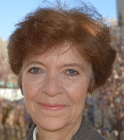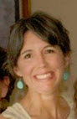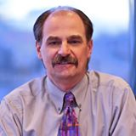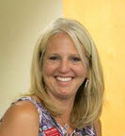

**Patti Smith**

Project Chair 2013

**RJ Clay** Videographer 2015

**Rachael Davis** Co-Chair 2013 Project Art Director/Portrait Artist 2013

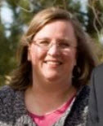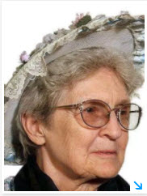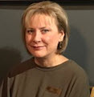

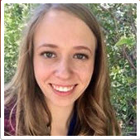

**Kirsten Johnson**

Corresponding Secretary 2014

**Barbara Fleming** Writer Extraordinaire Author 2015

**Michel Olds** Foundation Treasurer 2016

**Stacey Jensen** Grant Writer 2016

**Angela Kettle** Online Fundraising 2016

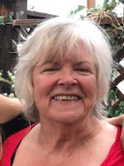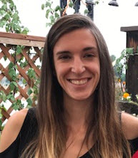

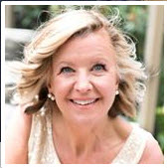

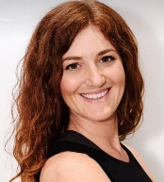

11

**Trish Murtha** Role Model-Art Workshop Facilitator/ Portrait Artist 2017

**Isis Lanigan** Portrait Artist 2017

**Alyse Smith** Graphic Designer 2017

**Julie Ulstrup** Photographer 2017

**First Twelve Notable Women Selected**

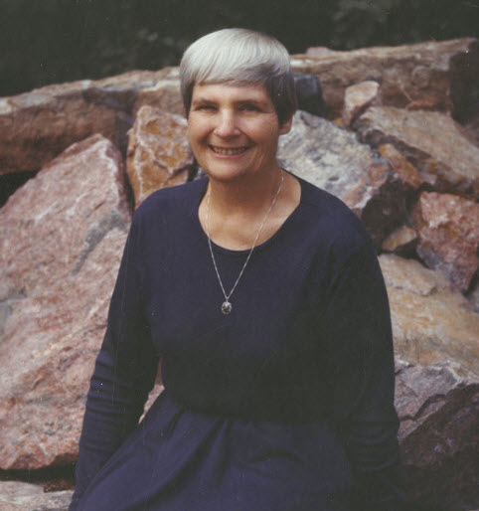 Ann Azari  Becky Hammon 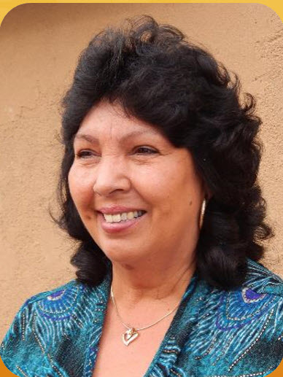

Brownie McGraw  Denise Freestone 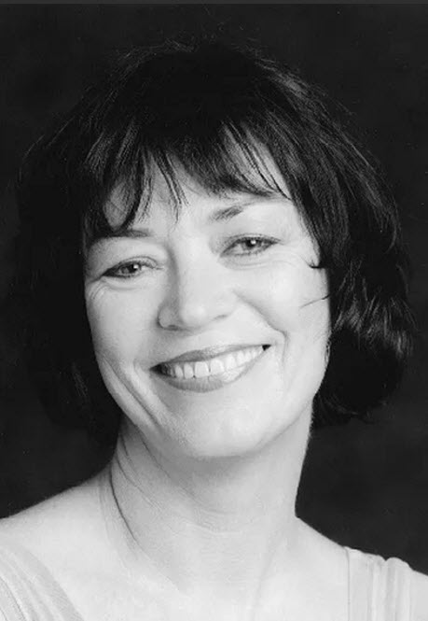 Auntie Elizabeth Stone 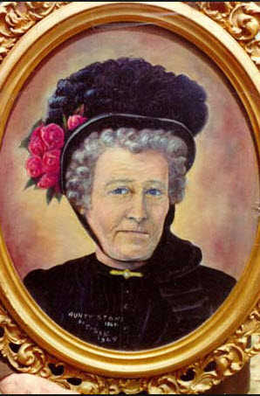

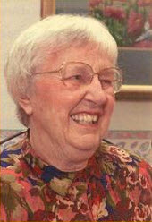 Glady L. Eddy 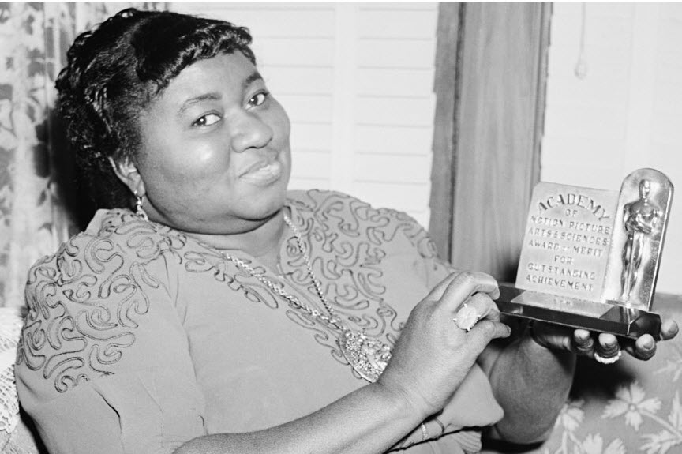 Hattie McDaniel 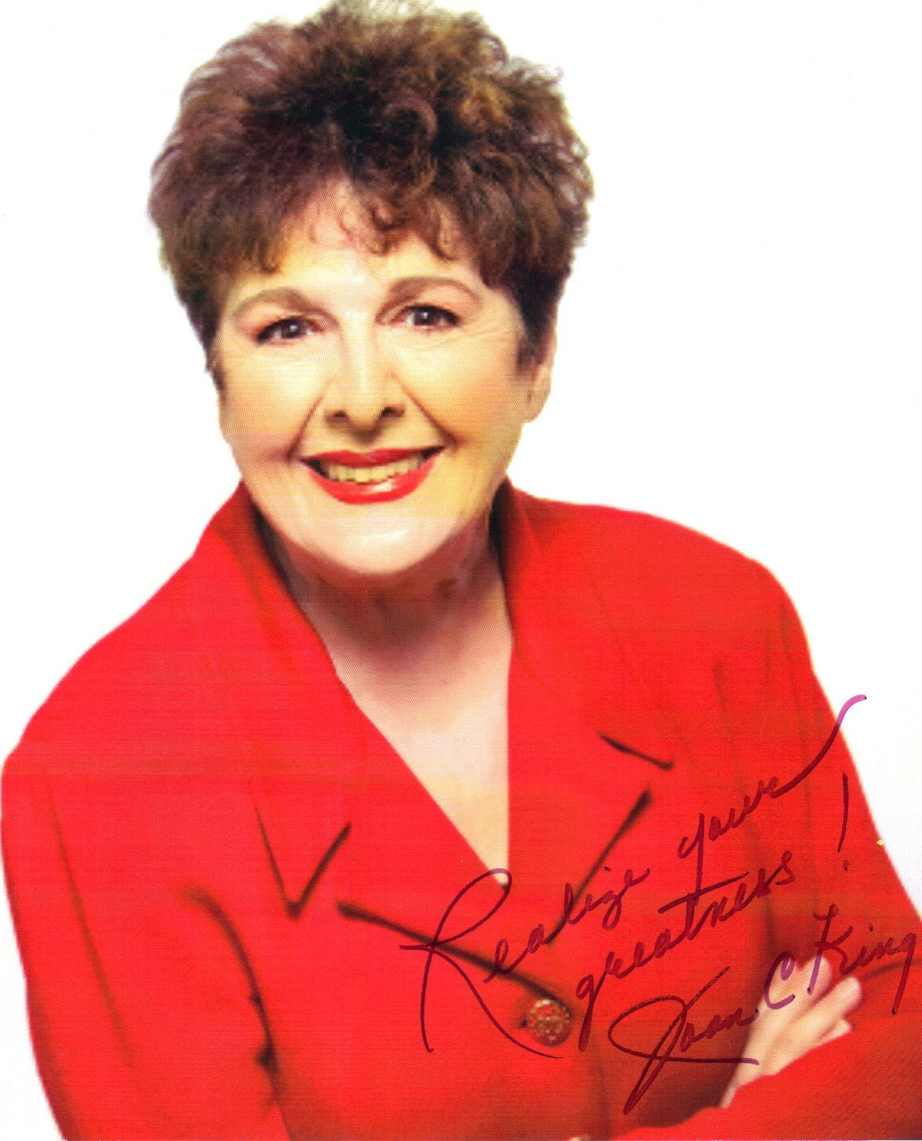 Dr. Joan King

 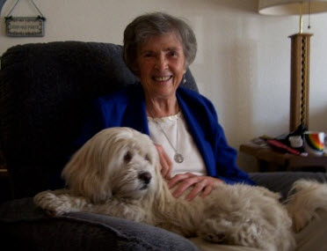 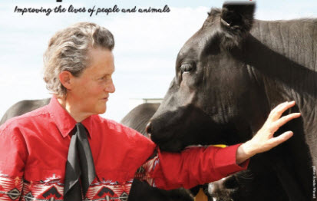

We invite you to visit our website to view the first 24 notable women chosen for recognition at [www.HerLegacyZontaFC.com](http://www.HerLegacyZontaFC.com).

Betty Aragon-Mitotes

Temple Grandin

Sister Mary Alice Murphy

Martha Trimble

12

**We Need Your Help**



You can make a difference! This year was successful, yet; we have a lot of work to do. Our funding to date has paid for all our marketing, individuals providing services to our project and our events held to date.

**Every Penny Matters**

Your donation will be put to good use as 100% goes to fund this historic women’s art exhibit project. Right now, we need your help to continue moving this project forward. We need $ 27,700 to finish paying for the first three bronze decorative frames and portrait panels so that we can hold the first unveiling event MAR 2018. Our first goal is $10,000 by NOV 16, 2017. Our second goal is $17,700 by December 28, 2017. Do you know anyone who supports the arts that you could introduce to us and we will share our public women’s art exhibit with them?

If 20 people donate $500 or if 50 people donate $200 or if 100 people donate $100 or if 200 people donate $50 or if 400 people donate $25 we will meet our funding goal to pay for 1/3 of the bronze window frames in preparation of hosting the unveiling of the first twelve notable women in 2018. Our goal is to raise $10,000 by November 16, 2017. Will you help us?

Will you pick the donation amount that fits your budget or that you feel you can stretch up and make your donation today to become a Legacy Founding Partner? We are a 501c3 Charitable organization. You can make your donation today online here: [www.HerLegacyFCdonate.org](http://www.HerLegacyFCdonate.org).

You can also donate by mail if you prefer: *Make your check out to the Zonta Club of Fort Collins Foundation/Legacy Project and mail it to Zonta Club of Fort Collins Foundation, P.O. Box 272914, Fort Collins, CO 80527.*

*We look forward to welcoming you as one of our Legacy Founding Partner’s. With a $100 donation or more you will receive a book by author, mentor, and Life Coach Dr. Joan King’s estate. Joan is one of our notable women and her book title is A Life on Purpose: Wisdom at Work. The major benefit to a business with a $1000 or more donation is a permanent logo marketing their business on windows in Old Town.*

**Volunteer and Help Make a Difference**

Not everyone can make a financial contribution. We know there are folks who like to volunteer. If you like to volunteer, we invite you to consider assisting us with one or more of the following upcoming events. If you would like to help in anyway, please complete the following form and send it back to us.

Also, one way to volunteer and help move our project forward is to share our project with your family, friends and/or colleagues that you think also have a passion to support women’s issues. Maybe they would be either interested in learning about our project and/or might be willing to donate $25 or more? Thank you for your generosity over these past several years. We truly appreciate YOU!

* Volunteer with upcoming event for the Legacy Project: March 2018 Unveiling event, Summer High Tea Introduction event, Fall 2018 3rd Fundraiser event/Women’ Music Concert. 2018 Women Empowering Women Leadership Forum, Spring and Fall 2018 Donor Appreciation Event
* Volunteer in a different way with our Zonta Club help deliver yellow roses, help make birthing kits, help recognize high school young women who give back in our community, with women’s author fundraiser or any other project you might be interested in? List your interest here_________________________

Please visit our website http://www.HerLegacyZontaFC.com to learn more, or call us at 970.988.8529. You can also send this form by mail to our office at Zonta Fort Collins Legacy Project at P.O. Box 272914, Fort Collins, CO 80527.

**Name:** ____________________________ **Phone:** ___________________________

**Email:** ______________________________________________________________

**Address:** ____________________________________________________________

13

**December 2013-JULY 31, 2017**



**Initial Annual Report**

**nn**



**Connect With Us! @HerLegacyFortCollins**

970-988-8529 |HerLegacyFC@gmail.com